01_OVERVIEW_ANSWERS_FROM_GITHUB REPO

1. Draw a flowchart or write pseudocode to represent the logic of a program that allows the user to enter a value. The program multiplies the value by 10 and outputs the result.

*Answer*:

Flowchart

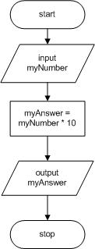

Pseudocode

start

input myNumber

myAnswer = myNumber * 10

output myAnswer

stop

1. Draw a flowchart or write pseudocode to represent the logic of a program that allows the user to enter a value for hours worked in a day. The program calculates the hours worked in a five-day week and the hours worked in a 252-day work year. The program outputs all the results.

*Answer*:

Flowchart

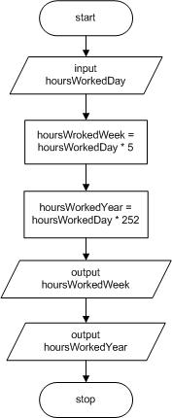

Pseudocode

start

input hoursWorkedDay

hoursWorkedWeek = hoursWorkedDay * 5

hoursWorkedYear = hoursWorkedDay * 252

output hoursWorkedWeek

output hoursWorkedYear

stop

1. Draw a flowchart or write pseudocode to represent the logic of a program that allows the user to enter values for the current year and the user’s birth year. The program outputs the age of the user this year.

*Answer*:

Flowchart

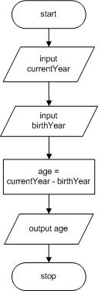

Pseudocode

start

input currentYear

input birthYear

age = currentYear - birthYear

output age

stop